|  |  |
| --- | --- |
| **Status** | Finished |
| **Started** | Monday, 30 December 2024, 11:20 AM |
| **Completed** | Monday, 30 December 2024, 11:27 AM |
| **Duration** | 6 mins 43 secs |

Top of Form

Question **1**

Correct

Marked out of 1.00

Flag question

Question text

Given a string, ***s***, consisting of alphabets and digits, find the frequency of each digit in the given string.

**Input Format**

The first line contains a string, ***num***which is the given number.

**Constraints**

***1 ≤ len(num) ≤ 1000***

All the elements of num are made of English alphabets and digits.

**Output Format**

Print ten space-separated integers in a single line denoting the frequency of each digit from ***0*** to ***9***.

**Sample Input 0**

a11472o5t6

**Sample Output 0**

0 2 1 0 1 1 1 1 0 0

**Explanation 0**

In the given string:

·         ***1*** occurs two times.

·         ***2, 4, 5, 6*** and ***7*** occur one time each.

The remaining digits ***0, 3, 8*** and ***9*** don't occur at all.

Answer:(penalty regime: 0 %)

Bottom of Form

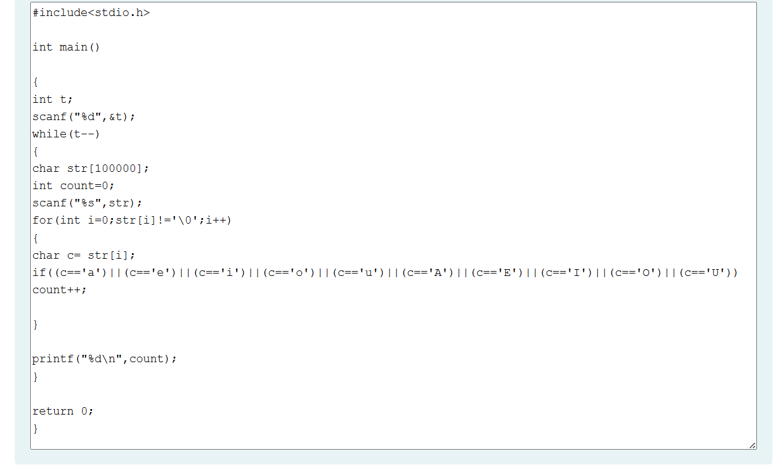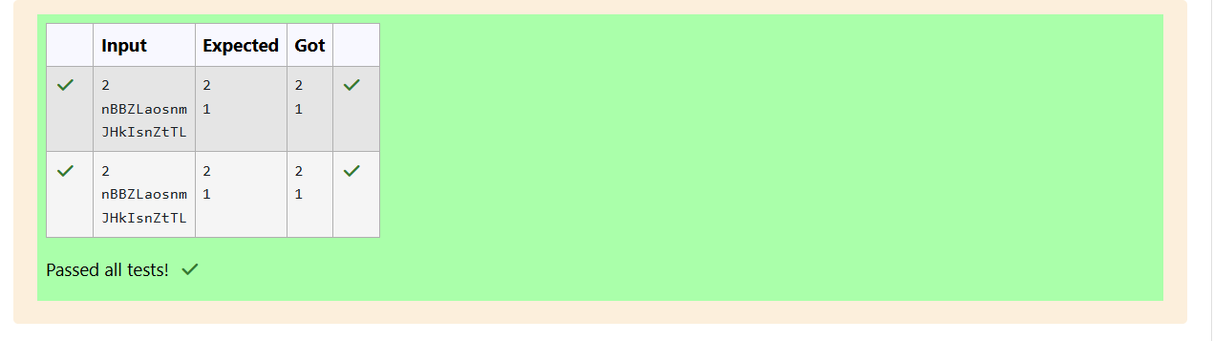Passed all tests!

Question **3**

Correct

Marked out of 1.00

Flag question

Question text

Given a sentence, ***s***, print each word of the sentence in a new line.

**Input Format**

The first and only line contains a sentence, ***s***.

**Constraints**

***1 ≤ len(s) ≤ 1000***

**Output Format**

Print each word of the sentence in a new line.

**Sample Input 0**

This is C

**Sample Output 0**

This

is

C

**Explanation 0**

In the given string, there are three words ["This", "is", "C"]. We have to print each of these words in a new line.

Answer:(penalty regime: 0 %)

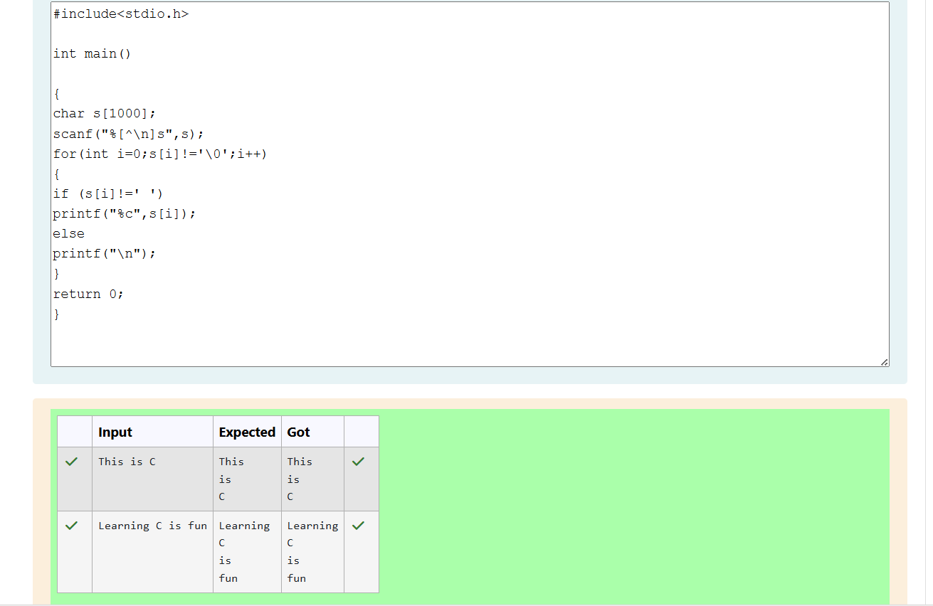  
abcdef

ebcd af

**Explanation**

a = "abcd"

b = "ef"

|a| = 4

|b| = 2

a + b = "abcdef"

a' = "ebcd"

b' = "af"

Answer:(penalty regime: 0 %)

